Zero Trust Architecture (ZTA)
Zero Trust Architecture (ZTA) is a security model based on the principle "Never Trust, Always Verify." Unlike traditional security models that trust users after they enter the network, Zero Trust continuously verifies every user, device, and application before granting access to resources.
The goal of Zero Trust is to minimize unauthorized access, prevent lateral movement, and protect critical assets in cloud, hybrid, and on-premises environments.
Traditional Approach
If an attacker gains network access through stolen credentials or a compromised device, they can potentially access multiple systems.
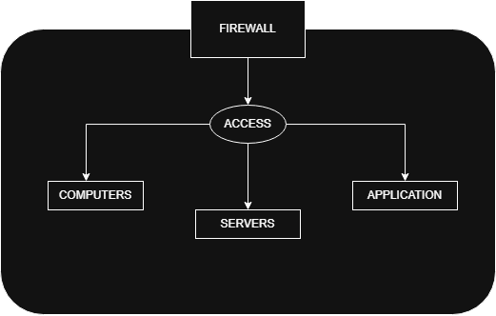
Core Principles of Zero Trust
1. Verify Explicitly
Every access request is verified using:
- User identity
- Multi-Factor Authentication (MFA)
- Device health
- Location and risk level
- Requested resource
Ensure only authenticated and authorized entities receive access.
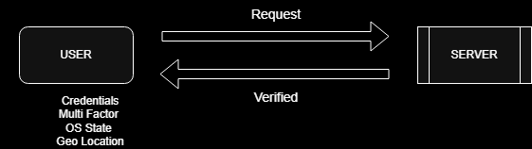
2. Least Privilege Access
Users receive only the permissions required for their role.
Examples
Role | Allowed Access
HR Employee | HR Portal
Developer | Development Environment
Finance Staff | Financial Systems
Reduce attack surface and limit unauthorized access.
3. Assume Breach
Zero Trust assumes attackers may already be inside the environment.
Security controls focus on:
- Continuous monitoring
- Threat detection
- Network segmentation
- Incident response
Minimize damage if a compromise occurs.
